

**YEAR: 10**

**SUBJECT: Science**

**Chemistry Term 1**

**Please do not mark this paper.**

**Year 10 Chemistry Test**

**Part A: Multiple Choice 15 marks**

**Record answers in the answer booklet provided.**

1. Which of the following best describes the smallest sub-atomic particle with a negative charge?

(a) A neutron.

(b) A molecule.

(c) An electron.

(d) A proton.

2. The periodic table:

(a) is a systematic chart listing all known elements

(b) arranges elements from lowest to highest atomic number

(c) separates the metals and non-metals

(d) all of the above

3. A vertical column of elements on the periodic table is called a

(a) series

(b) period

(c) list

(d) group

4. Below is the electron configuration diagram for magnesium:

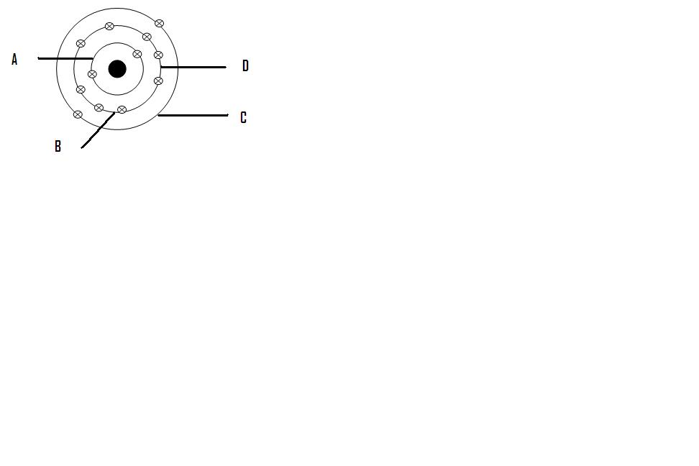

What is the valence configuration for Magnesium as shown in the above diagram?

1. Mg
2. Mg2+
3. Mg3+
4. Mg+

5. A horizontal row of elements on the periodic table is called a

(a) group

(b) period

(c) family

(d) list

6. Haematite, Fe2O3, is not found in the periodic table because

(a) it has properties different from the metals in any other group

(b) it is not an element

(c) it is only a recent discovery

(d) its relative atomic mass is too great

7. Which of the following has an atomic number of 12 and has 2 electrons in its valence shell?

(a) Be

(b) C

(c) Na

(d) Mg

8. Nitrogen N is in period 2, group 15. Which of the following elements would have properties most similar to nitrogen?

(a) phosphorus P (period 3, group 15)

(b) oxygen O (period 2, group 16)

(c) neon Ne (period 2, group 18)

(d) sodium Na, because its symbol also starts with N

9. The figure below shows the atomic symbol of element X:

15

X

7

Which of the following is the correct electron configuration for element X?

(a) 2 , 5

(b) 2 , 6

(c) 2 , 7

(d) 2 ,8, 5

10. The table below shows information about particles A and B

|  |  |  |
| --- | --- | --- |
| Particle | Proton number | Electron arrangement |
| A | 11 | 2 , 8 |
| B | 19 | 2 , 8 , 8 |

Based on the information provided, A and B are:

(a) positive ions

(b) negative ions

(c) noble gases

(d) isotopes of the same element

11. Which is the most reactive non-metal element?

(a) Sodium.

(b) Potassium.

(c) Chlorine.

(d) Fluorine.

12. When atoms lose electrons, they form:

(a) negative ions

(b) positive ions

(c) neutral ions

(d) Positive and negative ions, depending on their position in the Periodic Table

13. In which group of the periodic table are the halogens found? Group

(a) 1

(b) 2

(c) 17

(d) 18.

14. Which of these are ALL non-metals?

1. Zinc, carbon, phosphorous
2. Iron, nickel, aluminium
3. Sulfur, iodine, argon
4. Tin, gold, mercury

15. A substance has the following properties:

* high melting point
* liquid conducts electricity
* solid is brittle

The type of bonding present in this substance is

1. Molecular
2. Metallic
3. Ionic
4. Covalent



**Term One 2018 Chemistry Test ANSWER BOOKLET**

**NAME:**

**FORM: DATE:**

**Multiple Choice Short Answer Extended Answer Total**

**/62**

**/4**

**/43**

**/15**

**SECTION ONE: Multiple choice answers**

**Cross (X) through the correct answer.**

|  |  |  |  |  |
| --- | --- | --- | --- | --- |
| **1** | **a** | **b** | **c** | **d** |
| **2** | **a** | **b** | **c** | **d** |
| **3** | **a** | **b** | **c** | **d** |
| **4** | **a** | **b** | **c** | **d** |
| **5** | **a** | **b** | **c** | **d** |
| **6** | **a** | **b** | **c** | **d** |
| **7** | **a** | **b** | **c** | **d** |
| **8** | **a** | **b** | **c** | **d** |
| **9** | **a** | **b** | **c** | **d** |
| **10** | **a** | **b** | **c** | **d** |
| **11** | **a** | **b** | **c** | **d** |
| **12** | **a** | **b** | **c** | **d** |
| **13** | **a** | **b** | **c** | **d** |
| **14** | **a** | **b** | **c** | **d** |
| **15** | **a** | **b** | **c** | **d** |

**Part B: Short Answer 43 marks**

1. Chlorine is represented as 35 Cl17 (2 marks)

Answer the following questions in relation to this isotope:

(a) The mass number is________________________

(b) The atomic number is_______________________

(c) The number of neutrons in the nucleus is____________________

(d) The number of electrons in a neutral atom is_____________________

2. Complete the following table: (8 marks)

|  |  |  |  |  |  |
| --- | --- | --- | --- | --- | --- |
| **Element** | **Symbol** | **Atomic number** | **Number of electrons** | **Electron shell diagram** | **Electron configuration** |
| Sodium |  |  |  |  |  |
| Chlorine |  |  |  |  |  |

3. Complete the following table: (8 marks)

|  |  |  |  |  |  |
| --- | --- | --- | --- | --- | --- |
| **Element** | **Symbol** | **Atomic number** | **Number of electrons** | **Electron shell diagram** | **Electron configuration** |
| Sodium ion |  |  |  |  |  |
| Chlorine  ion |  |  |  |  |  |

4. State the period and group of the Periodic Table of the elements with the following

electron arrangements: (6 marks)

|  |  |  |  |  |
| --- | --- | --- | --- | --- |
| Electron arrangement | Element symbol | Period | Group | Valence electron |
| 2,8 |  |  |  |  |
| 2,8,5 |  |  |  |  |
| 2,8,8,1 |  |  |  |  |

5. Explain, in terms of atomic structure, why helium is used in balloons instead of hydrogen.

(4 marks)

__________________________________________________________________________________________________________________________________________________________________________________________________________________________________________________________________________________________________________________________________________________________________________________________________________________________

6. Given the substances below, predict the type of bonding that would exist between the molecules:

(3 marks)

Sugar _________________________

Salt _________________________

Solder _________________________

7. When **sodium** is added to **water**, the **sodium** melts to form a ball that moves around on the surface.

(3 marks)

a) Complete the word equation below.

Sodium + water 🡪 ________________ + __________________

b) Write the chemical formulae.

_______________ + ______________ 🡪 _______________ + ________________

c) Balance the above chemical equation.

____________________________________________________________________________

8. There are groups on the periodic table with special characteristics. These are groups

1, 17, 18 on the periodic table. Complete the table below. (9 marks)

|  |  |  |  |
| --- | --- | --- | --- |
| **Group** | **Special name** | **Properties** | **Reactivity trends** |
| 1 |  |  |  |
| 17 |  |  |  |
| 18 |  |  |  |

**Part C: Extended answer** **(4 marks)**

1. Tin acts like a non-metal below 13 ℃. In 1913 Captain Robert Scott and two fellow explorers froze to death in Antarctica after they ran out of liquid heating fuel that was stored in tin cans on the surface. Use the properties of metals and non-metals to propose reasons why they unexpectedly ran out.

_______________________________________________________________________________

_______________________________________________________________________________

_______________________________________________________________________________

_______________________________________________________________________________

_______________________________________________________________________________

_______________________________________________________________________________

_______________________________________________________________________________

_______________________________________________________________________________

_______________________________________________________________________________

_______________________________________________________________________________

_______________________________________________________________________________

______________________________________________________________________________